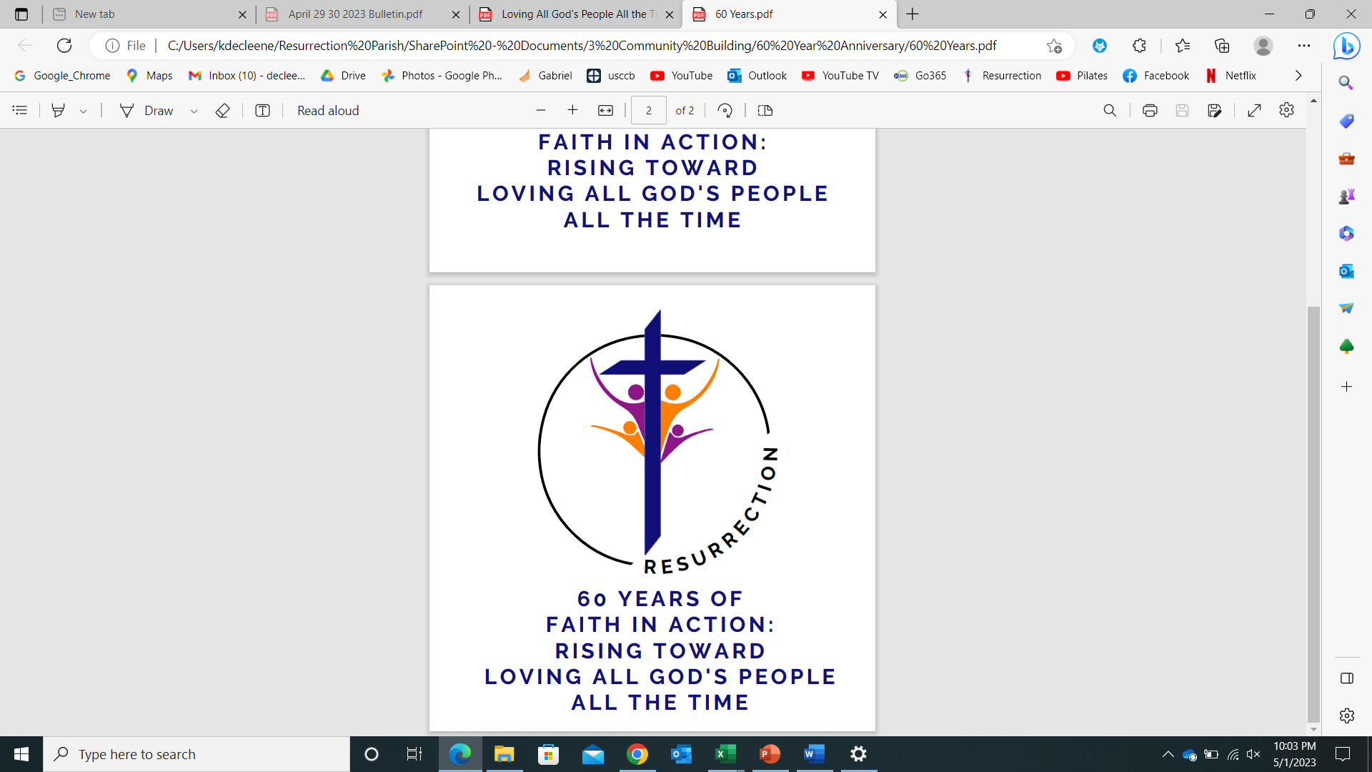

**Baptism - Resurrection Catholic Parish**

Congratulations! It is our great joy and privilege that you are considering Resurrection Catholic Parish for your child’s Baptism. A Catholic Baptism is a celebration of a new Christian in the world. The normative is that Baptism is celebrated in a community of believers during Mass. Therefore, when parents choose to have their child baptized at our parish we assume that they share the values and beliefs of the community. In the Catholic Sacrament of Baptism you are making a commitment to raise your child in the Catholic faith, which means active participation in a parish. All couples that are not current members at Resurrection Catholic Parish will need a letter of good standing from their current parish and approval from their pastor. If your child is 7+, contact the parish office regarding the OCIA process.

**Church Requirements for Parents**

● One parent must be a practicing Catholic:

○ Someone who accepts and strives to live the teachings and commandments of Jesus and His Church

○ One who regularly participates in the worship of the Church. This means receiving the Sacraments regularly and supporting the parish financially and through volunteering – sharing time, talent and treasure.

● One or both parents must be registered members of a Catholic parish.

Consider membership at Resurrection Catholic Parish (learn more at: www.gbres.org/newparishioner).

● First time parents must attend a baptismal preparation class prior to their first child’s Baptism.

**Church Requirements for Non-Parishioners**

● Members of another Catholic parish wishing to have a Baptism at Resurrection must have a “Letter of Good Standing” and approval from the pastor of the parish they attend. This letter tells us that they are active, registered members in that parish.

**Church Requirements for Godparents**

* At least one godparent is required.
* If there are two godparents, they may not be of the same gender (so the child has both a male and a female role model).
* At least one godparent must be at least 16 years old and have received Baptism, First Communion and Confirmation.
* Godparents must be practicing the Catholic faith – living a life consistent with the faith and morals taught by the Roman Catholic Church; participating in the Sacraments.
* There may be no more than two godparents on the baptismal certificate, however additional persons will be considered witnesses.
* A non-Catholic may witness a baptism as a “Christian Witness” (not a godparent). If you have a non-Catholic for a witness you still need a Catholic godparent.
* These are laws of the Church with no exceptions

**Cost**

● There is $25 fee that covers the cost of materials that you will receive during the baptism preparation class and during Baptism.

● It is customary to offer the presider a stipend at your discretion. Questions?

● Parish Contact info:

○ Phone: (920) 336-7768

○ Email: resurrectionparish@gbres.org

● Further resources: Catholic Diocese of Green Bay - [www.gbdioc.org](http://www.gbdioc.org)

**Date of Baptism**

● The Catholic Tradition prefers that we do not baptize during the season of Lent as the focus during Lent is on Prayer, Fasting and Almsgiving. Exception can be made under certain circumstances.

● We do not baptize within Mass on All Soul’s Day.

● We do not baptize on the first Sunday of Advent.

● We welcome baptisms at almost any other time. Contact the parish office if you have questions.

**Church Requirements for Presiders**

● A Catholic priest or deacon that is in good standing within their diocese and home parish